300-BLK Howa 1500 MiniAction Heavy Barrel 16"
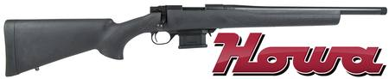
300BLK-021

Are you wanting a quiet, subsonic rifle? Then .300 Blackout is a great option and a Kiwi favourite. Based on the .223 case, the cartridge is beautiful and small which means the magazines and actions are compact. In most cases, it shares the same magazines and actions as the .223.
This, in turn, means that you carry more ammunition in a smaller magazine than the likes of .308 while still be able to send a 200-240 grain subsonic projectile downrange with the same ability to suppress as a subsonic .308 round. In most cases, the barrel twist from the factory is set up to allow it to be accurate for both subsonic and high-velocity loads.
Powerful enough for hunting most New Zealand game animals, this cartridge is ideal for hunting on properties where you are not wanting to upset neighbours when used with a silencer. Because the subsonic loads are very quiet (similar to a .22 LR using high velocity with a silencer) it will help ensure you don’t scare game off in the distance, increasing your chances of having a greater hunting experience.
The off-the-shelf ammunition options are great; ranging from 110-grain through to 220-grain at prices less than .308. The .300 Blackout is a truly great addition to any Kiwi hunters gun safe.
Unlike most rifles chambered for the .300 BLK, the Howa MiniAction is a bolt-action platform that's smaller than the traditional short-action receivers usually seen in the bolt-rifle world. These even-shorter rifles are optimised to feed many of today's popular AR-length cartridges, and the .300 BLK is one of the latest chamberings in the MiniAction lineup.
Howa MiniAction chamber and bolt are 12% shorter than regular short actions with shorter bolt throw for faster reloads. 18½" barrel, three-position safety, and H.A.C.T. two-stage trigger. Factory equipped with a ten round, synthetic detachable magazine. Lightweight and Fast!
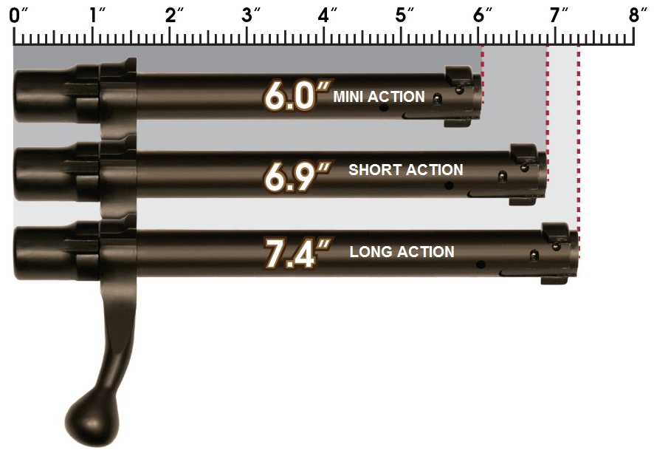
Ultimately, the principal benefit of having a bolt-action rifle chambered in .300 BLK is to take advantage of the many subsonic offerings on the market. These quiet rounds, combined with a suppressor, have made .300 BLK rifles popular among shooters looking to achieve the most sound-reduction possible in their rifle platform. However, today's rifles equipped with semi-automatic operating systems, feature internal mechanisms that still create loud noises, particularly when the bolt closes on locking lugs. A bolt-action rifle like the Howa MiniAction removes this variable, allowing users to have an incredibly quiet platform.
Each Howa MiniAction chambered in .300 BLK is ideally suited to serve as a suppressor platform, having been equipped with an 18½" heavy barrel topped with a threaded muzzle. Muzzle threads are cut with a 5/8x24 TPI thread pitch, which is compatible with most of today's .30 calibre sound suppressors. When equipped with a sound suppressor, hunters, in particular, can take advantage of this quiet platform while in the woods, enabling them to take game without spooking other animals in the area or damaging their hearing.
The other benefit of a .300-BLK, bolt-action platform like the Howa MiniAction is for new shooters, who may be both sound- and recoil-averse. The AR-length cartridge chambered in a heavy-barreled rifle produces little felt recoil, and the use of subsonic ammunition combined with a solid suppressor makes for an easy, comfortable starting point for those stepping into the shooting sports.
Each Howa MiniAction rifle chambered in .300 BLK is set inside of an HTI synthetic stock, complete with a pillar-bedded action and recoil pad. The stock is textured along the fore-end and wrist and features sling-swivel studs at the front and rear. Each rifle is equipped with a proprietary, detachable magazine holding 10 rounds. Each rifle is equipped with the company's HACT two-stage trigger, short bolt throw, and a three-position safety.
Specifications:
• Calibre: 300 Blackout
• Action: Bolt action
• Barrel Length: 16"
• Barrel Thread: 5/8x24
• Stock: Black synthetic
• Finish: Black blued
• Magazine: 10-round detachable magazine

